**FINAL TERM EXAM**

|  |  |
| --- | --- |
| **Student Name** | Mazaharuddin Mohammad |
| **Student Number** | N01464978 |
| **Subject Name** | Big Data 1 - ITE-5200-IRA |
| **Professor Name** | Orren Johnson |

**Pig statement screenshot:**

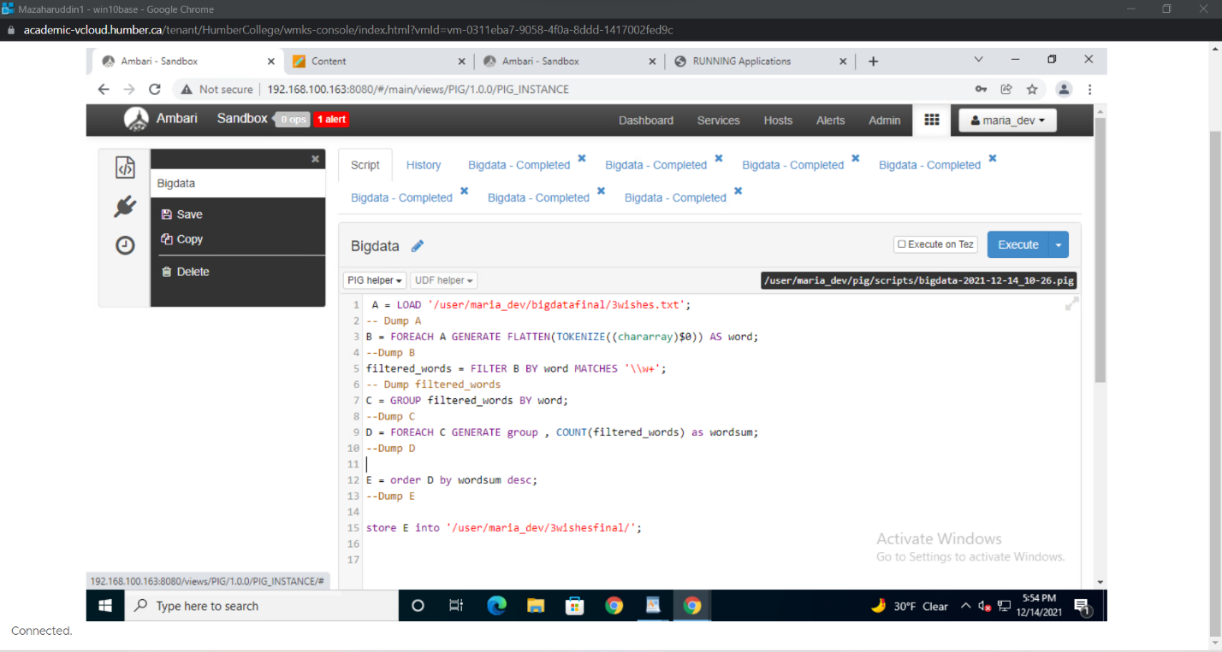

**Wishes hive table**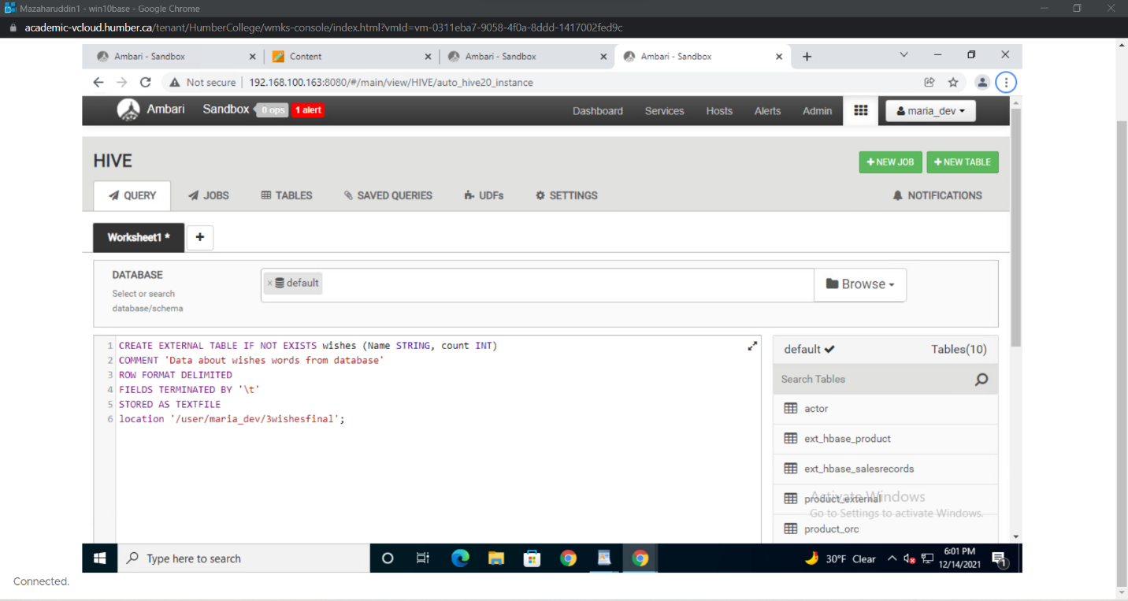

**Access hive table:**

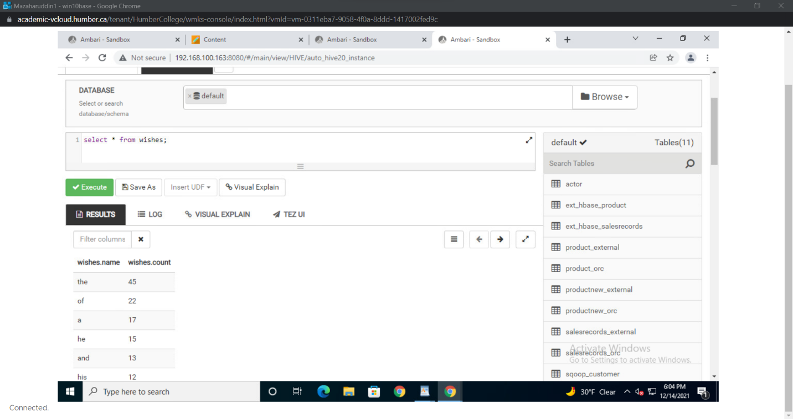

**Dataframe and wishes table from Zeppelin**

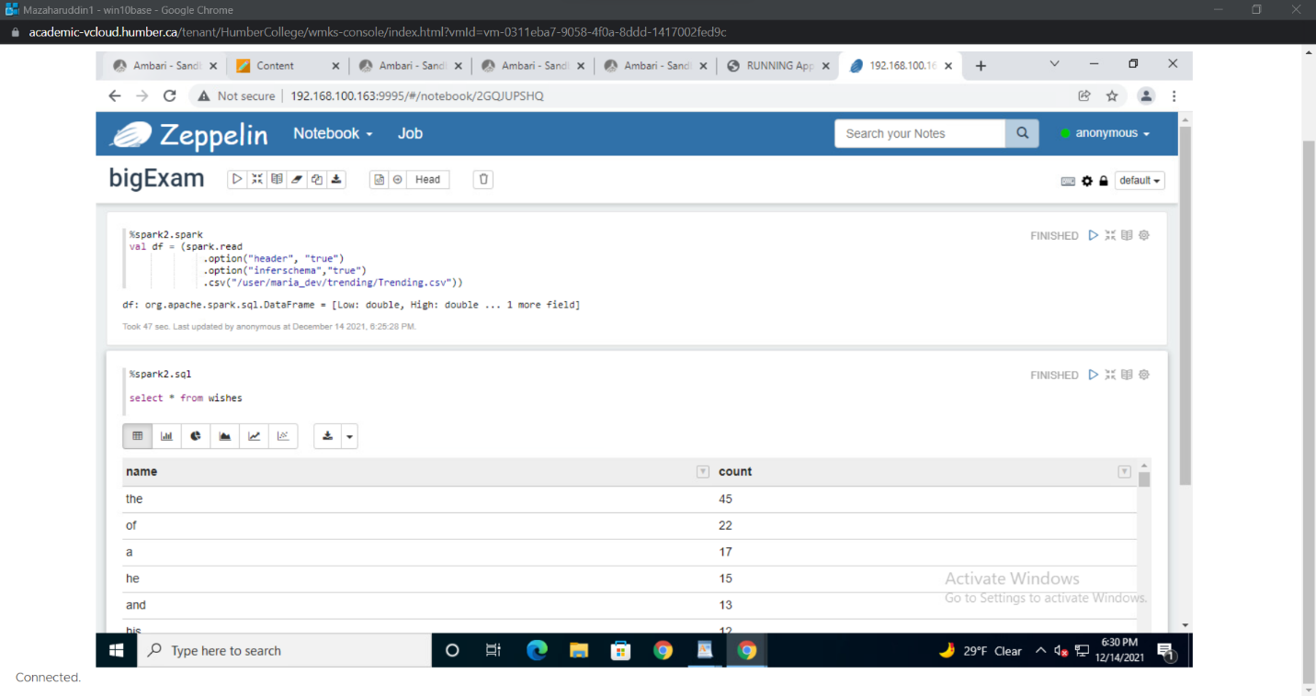

**Tempview:**

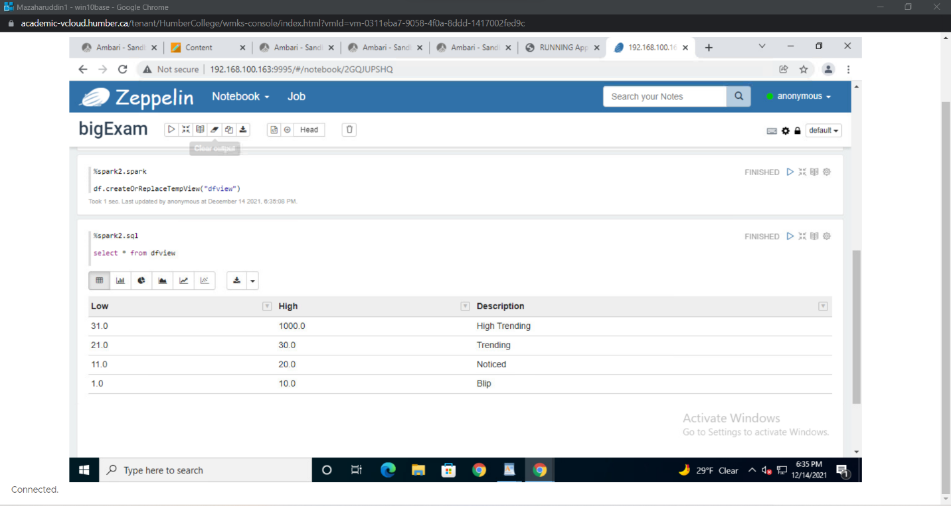

**Count:**

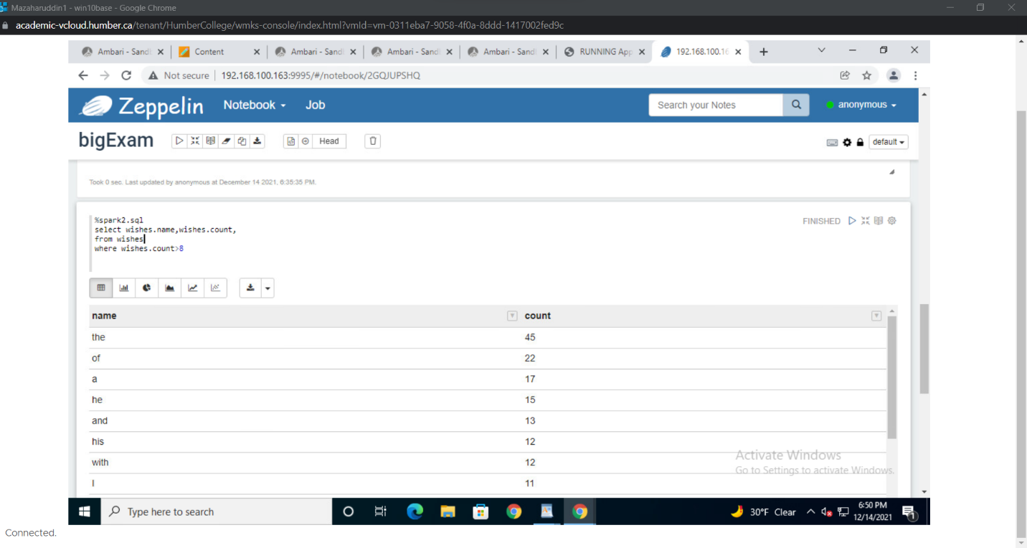

**Bargraph**

